create desktop shortcut launcher on Ubuntu 18.04

Create desktop shortcut launcher manually

gedit /home/user/Desktop/spyder.desktop

#!/usr/bin/env xdg-open
[Desktop Entry]
Version=1.0
Type=Application
Terminal=false
Icon[en_IN]=gnome-panel-launcher
Name[en_IN]=spyder
Exec=/home/jdf/anaconda3/bin/spyder
Comment[en_IN]=spyder
Name=spyder
Comment=spyder
Icon=gnome-panel-launcher

Save the above file in desktop.

[Desktop Entry]
Version=1.0
Type=Application
Name=PyCharm Community Edition
Icon=/home/jdf/pycharm-community-anaconda-2019.3.3/bin/pycharm.svg
Exec="/home/jdf/pycharm-community-anaconda-2019.3.3/bin/pycharm.sh" %f
Comment=Python IDE for Professional Developers
Categories=Development;IDE;
Terminal=false
StartupWMClass=jetbrains-pycharm-ce

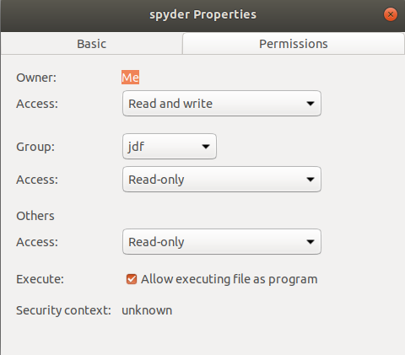

Properties-->Permissions-->Allow executing file as program

Now double click on the new icon and hit Trust and Launch button.

Program will lanch

Desktop Shortcut creation with gnome-desktop-item-edit

The gnome-desktop-item-edit command may be missing as it is not installed by default.
You can install it by opening up terminal and entering the following linux command:

$ sudo apt-get install --no-install-recommends gnome-panel

To create a new desktop shortcut launcher on Ubuntu 18.04 execute the following linux command:

$ gnome-desktop-item-edit ~/Desktop/ --create-new

Adding custom programs to favourites of Ubuntu

spyder.desktop

If you want this to be usable by anyone on your system, put it in /usr/share/applications.
For personal use only, you can put it in ~/.local/share/applications

Make the .desktop file executable by running chmod a+x ~/.local/share/applications/.desktop.

Refere

http://manpages.ubuntu.com/manpages/bionic/man1/gnome-desktop-item-edit.1.html

